Chapter 11, Problem 21.

Assuming that the load impedance is to be purely resistive, what load should be connected to terminals a-b of the circuits in Fig. 11.52 so that the maximum power is transferred to the load?

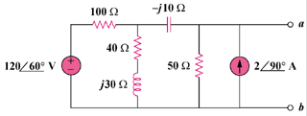

Figure 11.52
For Prob. 11.21.

